MEHRAN UNIVERSITY OF ENGINEERING & TECHNOLOGY, JAMSHORO

DEPARTMENT OF BIOMEDICAL ENGINEERING

SECOND TERM THIRD YEAR (10-BIOMEDICAL BATCH)
SESSIONAL THEORY TEST 2012

BIOMEDICAL CONTROL SYSTEMS

Date: 24-09-2012 Time Allowed: 20 Minutes. Max: Marks. 05.

Problem: Make a Routh table and tell how many roots of the following polynomial are in the right half-plane and in the left half-plane.

Solution:

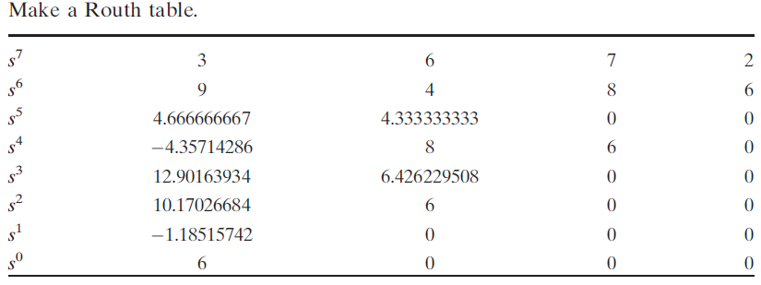

Four roots of the characteristic equation lie in the right half-plane (rhp), and three roots lie of the characteristic equation in the left half-plane (lhp). Therefore the system is unstable.

