MEHRAN UNIVERSITY OF ENGINEERING & TECHNOLOGY, JAMSHORO

DEPARTMENT OF BIOMEDICAL ENGINEERING

SECOND TERM THIRD YEAR (10-BIOMEDICAL BATCH)
SESSIONAL THEORY TEST 2012

BIOMEDICAL CONTROL SYSTEMS

Date: 29-08-2012 Time Allowed: 20 Minutes. Max: Marks. 05.

PROBLEM: If Z1(s) is the impedance of a 10 µF capacitor, and Z2(s) is the impedance of a 100 kΩ resistor, find the transfer function, G(s) = V_{o}(s)/V_{i}(s), if these components are used with;

- An inverting operational amplifier as shown in Figure (a).
- A non-inverting amplifier as shown in Figure (b).

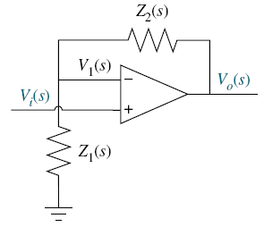
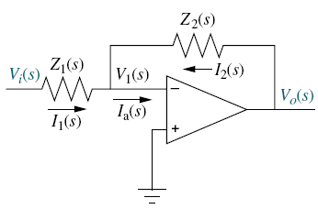
Figure: (b)
Figure: (a)

